Assignment

**write a program where you Assign a number to a variable, then write a random function where it keeps on running until it prints the number , using the for and the while loop**

1. i wrote the code to find the assinged number suing the for loop as below

Using for loop write a function that keeps running till the number is found

# Assign a number to a variable

number = 7

# Function that keeps running using a for loop until it prints the number

def find_number():

for i in range(1, 101):# Looping from 1 to 100 (or any upper limit)

if i == number:

print(f"Number found: {i}")

# Exit the loop once the number is found

# Call the function

find_number()

attached below is an image of the code after i ran it on the VSC

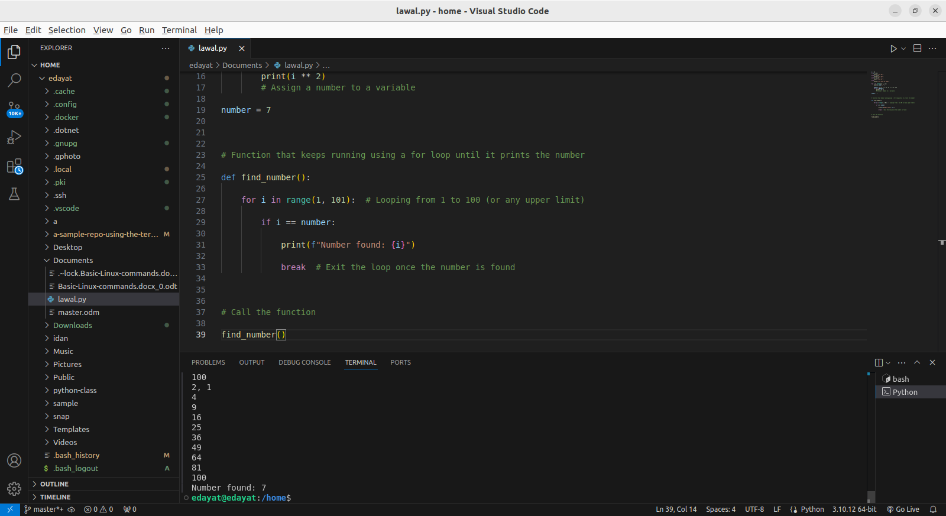

2. i wrote the code to find the assinged number suing the for loop as below

Using the while loop write a function that keeps running till the number is found

Using the while loop

# Assign a number to a variable

target_number = 7

# Define a function that runs until it prints the target number

def find_number():

number = 0# Start from 0

while number != target_number:# Keep running until number equals target_number

print(f"Current number: {number}")

number += 1# Increment the number

print(f"Found the number: {number}")

# Call the function

find_number()

attached belowis an image of the code after i ran it on the VSC

